The clock is ticking: Why Government Agencies Must Abandon Legacy Systems Now

Introduction
Around the world, government agencies are under pressure to do more with less - serve more citizens, respond faster, and protect more data, all while running on systems built for a different era. These legacy platforms, with siloed databases slow everything down, frustrating both citizens and public servants.
In this first part of a three-part series, we will unpack why modernization is no longer optional and why platforms like Salesforce Public Sector Solutions (PSS), and ServiceNows’ Public Sector Digital Services (PSDS) are becoming a backbone of the next-generation digital government.


The hidden cost of doing nothing
Many government systems were built decades ago in the wake of the internet revolution and were never designed for today’s volume of data, integrations, or security threats. Maintaining these legacy applications is expensive, and they often require specialized skills that are disappearing from the workforce.
Outdated and fragmented systems, and manual records management as major contributors to inefficiency, delays, and corruption risks. Agencies grapple with a constant backlog of IT change requests resulting in long queues, frustrated frontline staff who have to re-enter the same data multiple times, and citizens who lose confidence when basic services feel harder than ordering from an online store. 60% of individuals think government needs to modernize how it delivers services using newer technology (source: Salesforce “Connected Government Report,” as quoted by Cloud for Good)
Read more: Connected Citizens: Government Services In A Digital World

Shifts in citizen expectations
Surveys show that people increasingly expect government digital services to be as intuitive, seamless, and available as what they experience when using services from a company such as Amazon.
This means that citizens expect a certain ease of interaction, the ability to complete services online, and personalized experiences. When digital channels are confusing or unavailable, people fall back to in-person visits and paper forms, increasing costs for agencies and widening the digital divide. 60% of individuals think government needs to modernize how it delivers services using newer technology (source: Salesforce “Connected Government Report,” as quoted by Cloud for Good)
Citizen expectations have shifted decisively toward digital-first public services. In an Accenture survey, 92% of American citizens said better digital services would improve how they view government, while 73% said more digital services signal a forward‑thinking government. Nearly the same share (72%) said expanded digital services would both increase overall satisfaction with government and make them more willing to engage.
Read more: https://journalisslp.com/index.php/isslp/article/download/9/9/19


The 360-degree citizen vision
The modern digital government is built around a “360-degree view” of the citizen, bringing together data from benefits, permits, licensing, case management, and outreach into a single secure view.
Instead of each department maintaining its own partial record, agencies can see the full context of each individual or organization: past interactions, pending requests, eligibility, and communication history.
This kind of integrated view can dramatically improve coordination and speed of decision-making. This, to the citizen, feels personalized rather than bureaucratic.
Read more: https://www.oecd.org/content/dam/oecd/en/publications/reports/2019/05/the-impact-of-digital-government-on-citizen-well-being_a0df6881/24bac82f-en.pdf

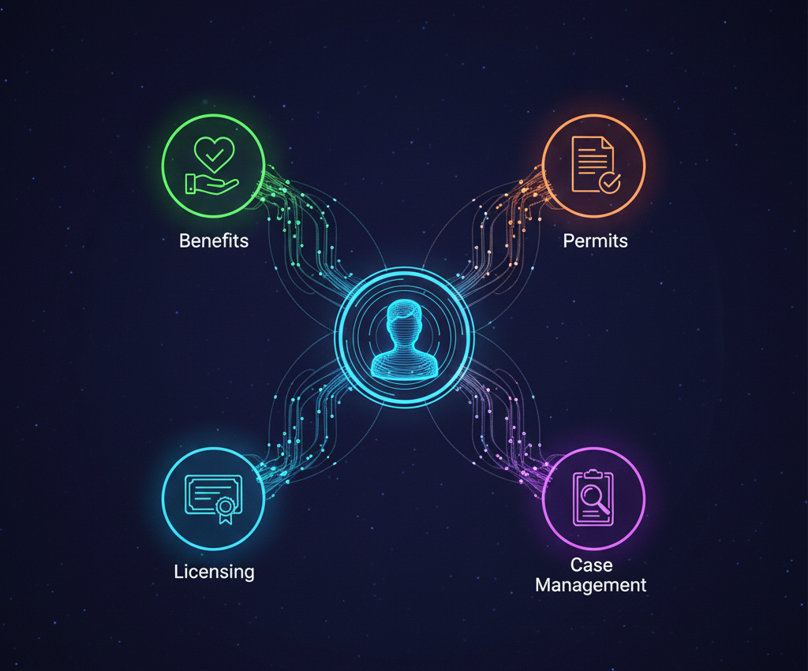

Why Salesforce Public Sector Solutions is a strong foundation
Salesforce Public Sector Solutions (PSS) provides a secure, scalable platform that helps governments move away from legacy systems without starting from scratch.
PSS offers prebuilt apps for benefits, licensing, permits, and case management, plus low-code/no-code tools that let IT teams and administrators configure processes quickly instead of writing everything from the ground up.
It has security standards that allow compliance with standards such the United States’ FedRAMP High with encryption, authentication and compliance controls built in.
Read more: https://cloud4good.com/announcements/empowering-state-and-local-government-with-salesforce-public-sector-solutions/

Lessons from both Kenya and North America
The modernization challenges facing county governments in Kenya - manual approvals, disconnected registries such as land registries, and slow service turnaround are surprisingly similar to those affecting cities and states in North America.
The difference is often in the tools and operating models: many North American governments are already piloting or scaling cloud platforms to centralize data, automate workflows, and enable more self-service for citizens.
By applying these lessons locally - using configurable platforms such as Salesforce PSS, embracing agile delivery, and focusing on the citizen journey-governements in Kenya and across Africa can move faster and avoid repeating the same legacy pitfalls.
Read more: https://kippra.or.ke/wp-content/uploads/2021/02/public-sector-reforms-in-kenya-challenges-and-opportunities-wp29.pdf



Conclusion: The Time for Band-Aid Solutions is Over
The clock isn't just ticking; the alarm is ringing. Legacy systems have evolved from mere technical inconveniences into active liabilities that erode public trust and stifle service delivery. The mandate is clear: governments must pivot from maintaining the past to architecting the future.
Modernization is no longer about buying new software; it is about survival in a digital-first world. Platforms like Salesforce PSS provide the secure, scalable foundation necessary to turn bureaucracy into a seamless, citizen-centric experience. However, a foundation is only the beginning.
In Part 2 of this series, we will move from strategy to execution. We will explore the critical role of specialized ISV partners like CLARITI, and demonstrate how Commercial Off-The-Shelf (COTS) solutions can help agencies bypass years of custom development to accelerate modernization and drastically reduce risk.

